The lower the variability, the higher probability that we will reject the null hypothesis.

Statistical power is the probability that the statistical test will reject a false null

hypothesis. (即，H0是false的，而且我们也正确地把HO给reject了)

Or, in plain English, Statistical power is the likelihood that a study will detect an effect when there is an effect there to be detected.

文心一言

Statistical power is the probability of rejecting a null hypothesis when it is false.

a measure of the sensitivity of a statistical test to detect effects or differences when they truly exist.

A higher power value indicates a greater chance of detecting a true effect, while a lower power value indicates a greater chance of failing to detect a true effect (i.e., a type II error).

Factors: sample size, effect size, significance level, data distribution.

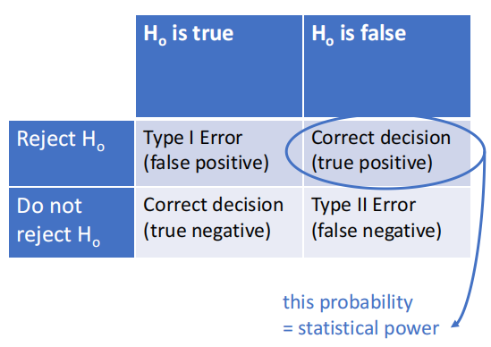

Type I error

• A Type I Error is rejecting the null hypothesis when it is true.

• Prob(Type I Error) = Significance level = P(reject Ho|Ho true)

Type II error

• A Type II error is not rejecting a null hypothesis when it is false.

• Prob(Type II Error) = β = P(accept Ho|H1 true)

• Value of β typically depends on which particular alternative hypothesis is true.

Power of a hypothesis test

• Power = 1 - β = P(reject Ho|H1 true)

• Probability of rejecting the null hypothesis if the alternative hypothesis is true

In clinical trials, Phase III: industry minimum power = 80%

Factors

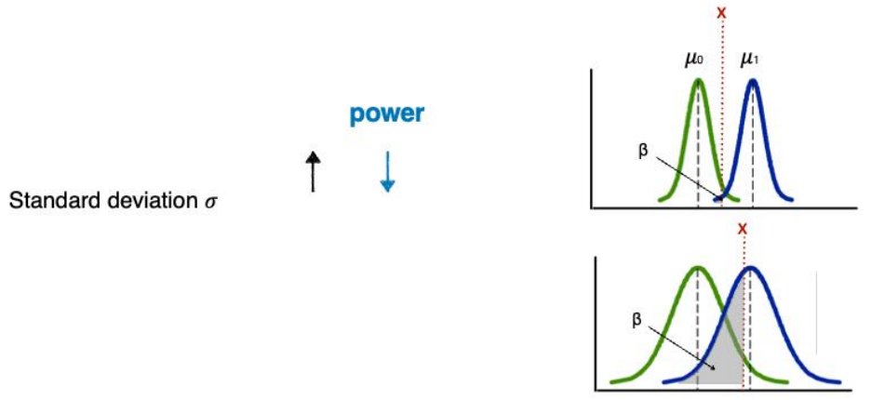

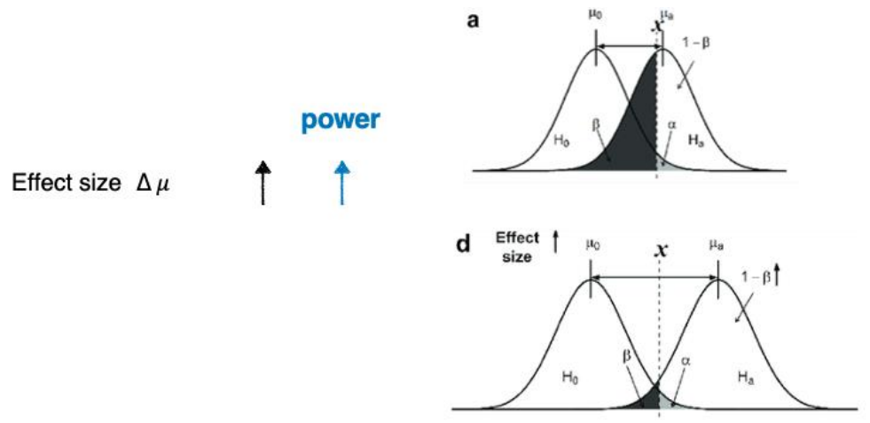

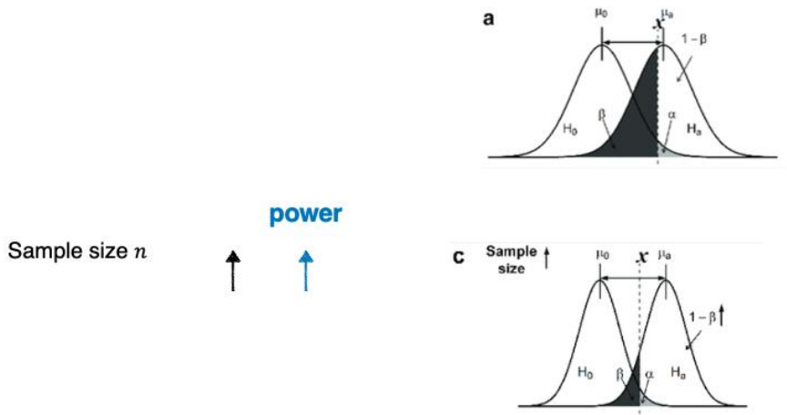

这个是有道理的。不是说increase sample size改变了standard deviation，我之前这样理解是谬论。如果把样本重复几遍，均值方差标准差都是不变的，但是依然增大了power。

而且还有一个惊人的发现，就是increase sample size之后居然更加normal了，因为shapiro test的p-value变小了！这应该就是上面文心一言回答我power与什么有关的时候告诉我与data distribution有关的原因。

文心一言

您提到的分母是n−1的情况通常是在计算样本方差时使用的，这是为了修正由于样本估计总体均值时带来的偏差。但是，当您明确知道整个数据集（即总体，而不是样本）的均值时，应该使用n作为分母来计算方差。

而我们这里画的是population distribution，不应该单纯从sample意义上分析这个问题。

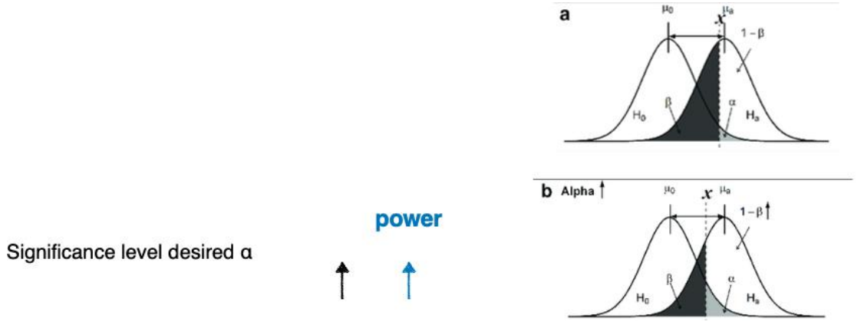

power.t.test()

做这个的时候比如说问你sample size要到达多少才行，就用power.t.test()算出来一个小数之后，再用power.t.test()验证一下

注意如果type = "two.sample"，无论你给定函数的n还是函数算出来的n都是number in each group,回答问题的时候要说明像这样：You require 46 students in each group (heavy vs non-heavy drinkers).

Problem set比较坑，他是这么问的What happens to our statistical power (increases or decreases) if we decrease our sample size to 10? 我们做的话是要理解成总样本量为10，即两个组加起来样本量为10，也就是说two-sample的话5 observations in each group